**Input for OCULUS**

[**https://developer.oculus.com/unity/**](https://developer.oculus.com/unity/)

Oculus Rift has three inputs: two Oculus Touch Controllers and one Oculus Remote.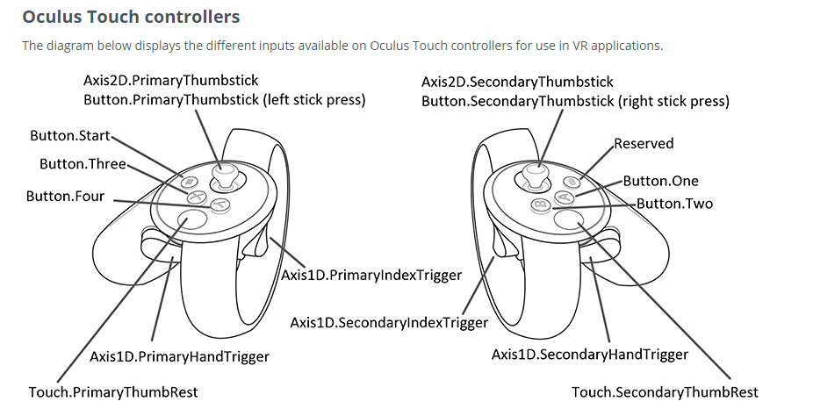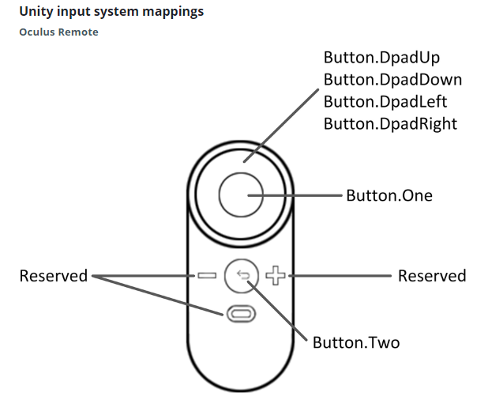

-For UI to select a button with the oculus head, we need to create a gaze Pointer from the center of the eye to the scene.

- <https://developer.oculus.com/blog/unitys-ui-system-in-vr/>

-To make sure that unity supports VR we need to check the following

